**HAZARDOUS AREA MONITORING**

**FOR**

**INDUSTRIAL PLANT POWERED BY IOT**

**PROJECT REPORT**

**DONE BY**

**VENGATALAKSHMI B**

**SWETHA S**

**VISHWA PRIYA R V**

**VISHALINI V**

**VAISHNAVI K R**

**CHAPTER 1**

**INTRODUCTION**

**1.1PROJECT OVERVIEW:**

The proper operation of the industrial process depends in large part on the core area of industrial safety. To ensure that the goods are safe and effective, it is critical to evaluate the status of the sector. An IoT-based industrial monitoring system with intelligent sensors is what this study aims to build. There may be a benefit to the industrial industry from this endeavour. Any manufacturing business that incorporates technology will guarantee the public's safety and wellbeing and prevent accidents.

**1.2PURPOSE:**

Internet of Things (IoT) represents a general concept for the ability of network devices to sense and collect data from the world around us, and then share that data across the Internet where it can be processed and utilized for various practical purposes in different aspects of life. The reach of IoT based systems in industrial areas is still limited, but it has huge potential. In this project, we create an IoT based hazard monitoring system specifically suited to requirements of mining, refining and manufacturing industries. The system actively records, processes and analyzes the temperature of surroundings, which is a prime safety parameter in areas where molten metal is processed, manufacturing is done or welds are made. Also, it keeps track of high levels of dangerous gases present in the environment (LPG/Natural Gas).If a parameter is violated, the system sends an immediate notification to a set of preset list of users on their smartphones, and continues logging and monitoring data for further analysis to suggest improvements in the safety regulations of the industry. The sensors used in this prototype model can be modified with industry requirements (for example more robust temperature sensor may be required in very harsh conditions) whenever the need arises.

**CHAPTER 2**

**LITERATURE REVIEW**

**2.1EXISTING PROBLEM:**

The existing detection systems are available to sense only a particular gas and they use GSM technology to indicate the critical situations. The drawback is that the detection system can send a message to only one person. The proposed system is made up of monitoring and alerting system through Internet of Things (IoTs).

**2.2REFERENCES:**

**1 . A Hazardous Area Personal Monitoring System for Operators in Gas**

**Depots and Storage Tanks**

Elia Landi, Lorenzo Parri*, Ada Fort, Marco Mugnaini, Valerio Vignoli, Dinesh Tamang, Marco Tani VOL. 91, 2022

The proposed system aims at reducing the risk of fires and explosions, thus increasing the safety of workers engaged in maintenance or inspection of gas storagesThe designed system can also increase plants safety by incorporating an intrusion detection system, which prevents unauthorized access to safety critical areas to prevent accidents. The sensor nodes transmit data through a LoRa low power radio channel to a remote server whereas they allow for the identification of the operators for the access to restricted areas exploiting a Bluetooth Low Energy (BLE) proximity technique.

2. **Hazardous Gas Monitoring System In Industries And Washrooms**

Divya.R, Latchaprabhu.P, Nishashree.R, Nivetha N.J, R. Kavitha ,

International Journal of Engineering and Advanced Technology (IJEAT) ISSN: 2249 – 8958, Volume-8, Issue-2S, December 2018

A gas detector is a vital device in industries that detects the presence of hazardous gases often as part of a safety system. This type of equipment is used to detect a gas leak or other emissions and provide signal and alarm giving the employees the opportunity to evacuate.The main gases in the washroom are hydrogen sulfide, methane, ammonia, carbonmonoxide and nitrogen oxides. This project is proposed to initiate the use of public washrooms in India without any hesitation. The gases are detected using sensors MQ-4, TGS-2602andMQ-136 respectively and GSM will send a message to the server GSM, which will indicate washroom should be cleaned.

**3. Environmental Surveillance Monitoring System In Industries Using Industrial Internet Of Things**

Ajay Sudhir,Bale Subhashish Tiwari K, Lova Raju Pravesh P,Kishore P,Vinayak N

This proposed system is not only a reliable solution for environment

surveillance but also an inexpensive and efficient one with effective visualization,which can be implemented in industries for real-time analysis. The Industrial Internet of Things (IIoT) is one best technology for this kind of application where there is a need for monitoring and alerting mechanisms with the communication between devices using unique identifiers (UID’s) over a network.

**4. IoT- Based Air Pollution Monitoring and Forecasting System**

Chen Xiaojun published a paper “IoT- Based Air Pollution Monitoring and

Forecasting System”in the year 2015

An IoT-based system for tracking and predicting air pollution In their article titled "UrbanAir Pollution Monitoring System With Forecasting Models," Khaled Bashir Shaban et al. made a recommendation for a low-cost air pollution monitoring system. The data could be received, stored, and preprocessed by the system. It has the ability to transform the data into insightful knowledge.

**5. IoT Based industrial Monitoring system**

Hemlata Yadav, Naomi oyiza, sarfaraz hassan, Dr.sumam lata,K. Jaya chitra This proposes the idea to reduce industrial risks in prominent factories, monitor powerplant yield, guarantee security in quickly developing industries, and access nuclear safety levels.

**2.3PROBLEM STATEMENT DEFINITION:**

A hazardous area is any area with an atmosphere containing, or potentially containing, gases, vapors or dust which are flammable or explosive. These areas are rigorously analyzed with condition monitoring when installing equipment to minimize the risk to individuals and assets. Hazard Monitoring describes the monitoring of machinery/equipment in classified areas to prevent catastrophic events from occurring. These events can include Dust Ignition Explosions, Gas Explosions, Belt Breakage, Motor Failure, and numerous other failures.A Plant Manager who needs to be informed of possible hazardous areas because it could pose a risk to the lives of the workers in the facilityand also some technician who needs to be informed when they are entering a hazardous area because it can lead to dangerous health complications and also the Safety Inspector who needs to easily ascertain whether the various areas of the plant are hazardous or not because he needs to provide accurate reports to ensure safety.

**CHAPTER 3**

**IDEATION & PROPOSED SOLUTION**

**3.1EMPATHY MAP CANVAS:**

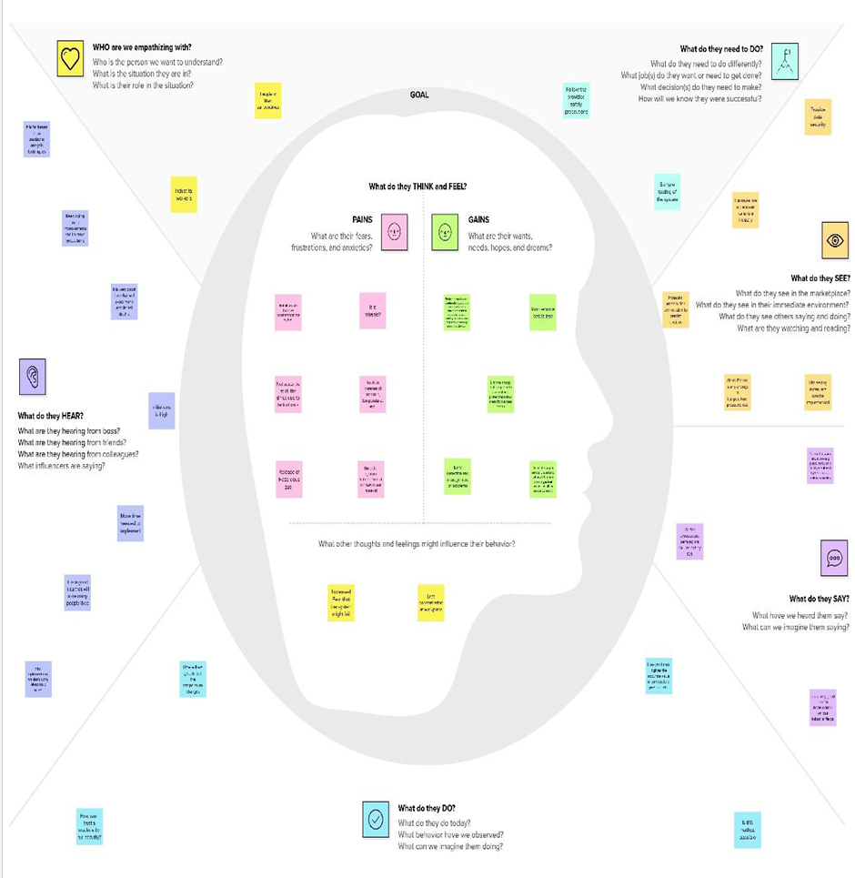

**3.2IDEATION AND BRAINSTORMING:**

**Step-1: Team Gathering, Collaboration and Select the Problem Statement**

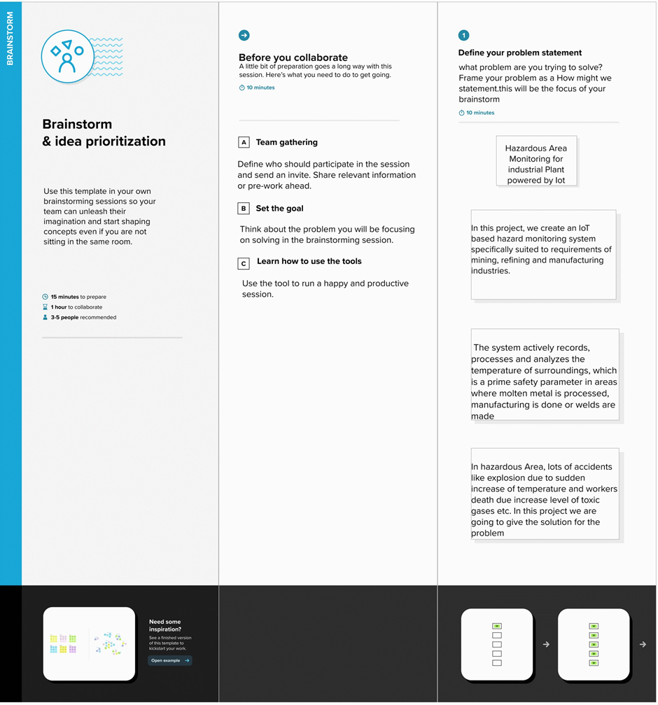

**Step-2: Brainstorm, Idea Listing and Grouping**

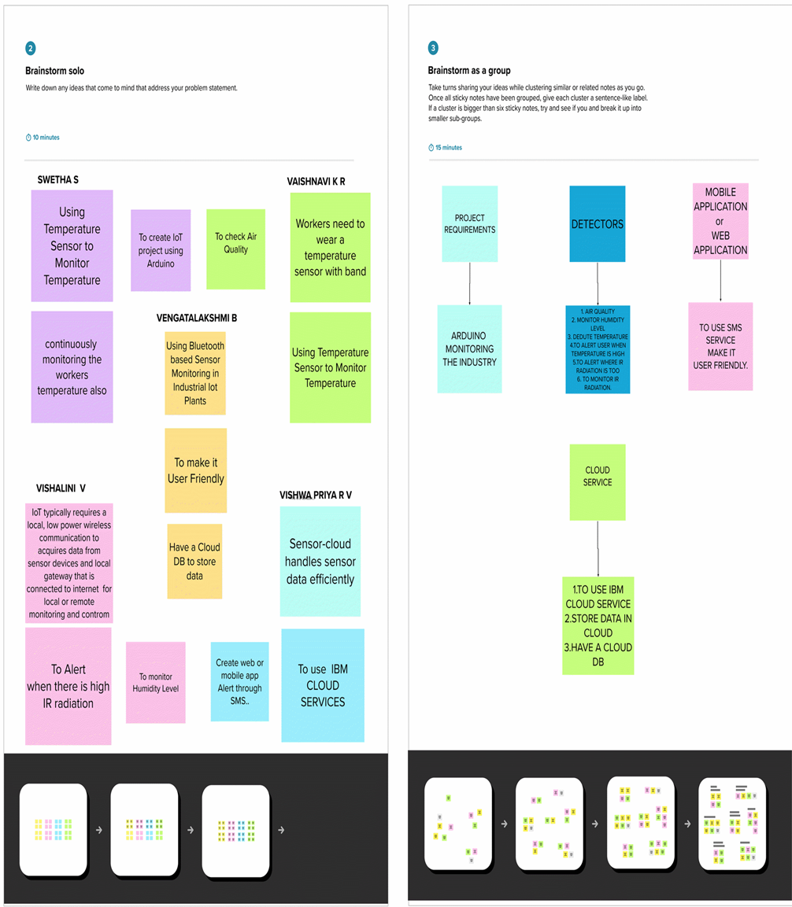

**Step-3: Idea Prioritization**

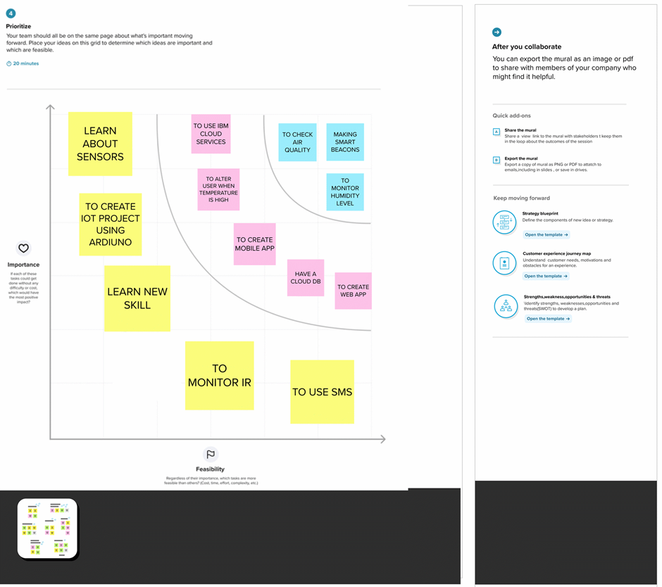

**3.3PROPOSED SOLUTION:**

Providing a wearable device which collects the data(temperature) via beacon sensors and displays it. An alert message is also sent to mobile whenever high temperature (or) toxic gasses are detected within the area through SMS using API. Ensuring precautions and safety of the workers.

➢ UNIQUENESS

➢ CUSTOMER SATISFACTION

➢ BUSINESS MODEL

➢ SCALABILITY OF THE SOLUTION

**UNIQUENESS**

Makes it easier to know the temperature (or) any hazardous gasses present in the area without the worker having to constantly do manual checks. Alerts on both the wearable device and mobile application occur simultaneously to prevent the worker from entering into hazardous areas. Alerts on both the wearable device and mobile application occur simultaneously to prevent the worker from entering into hazardous areas.

**CUSTOMER SATISFACTION**

**•** Ensures safety.

⦁ Saves lives of workers.

⦁ Comfortable & User-friendly.

⦁ Simple and reliable.

**BUSINESS MODEL**

Through our mobile application the revenue can be made in the form of pop-up advertisements, overlay ads from third party services. ⦁ Wearable devices can be priced and sold by the industry to the workers. Wearable devices can be priced and sold by the industry to the workers.

**SCALABILITY OF THE SOLUTION**

Huge. people can be supplied with wearable devices to ensure their safety and also Beacon sensors cover a large amount of area and supply data accurately and more readily. Every individual has to hols with wearable devices and mobile devices which provide information accordingly. It ensures the safety of each and every worker working in harmful gasses and high temperature environments.

**3.4PROBLEM SOLUTION FIT:**

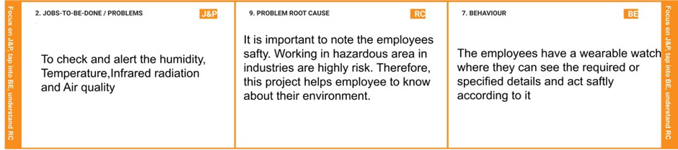

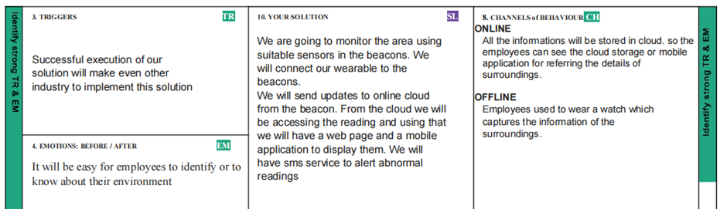

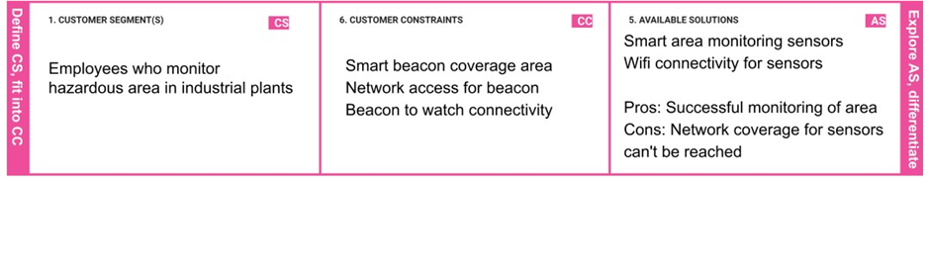

|  |
| --- |
|  |
|  |  |

**CHAPTER 4**

**REQUIREMENT ANALYSIS**

**4.1 FUNCTIONAL REQUIREMENT**

Following are the functional requirements of the proposed solution.

|  |  |  |
| --- | --- | --- |
| **FR No.** | **Functional Requirement (Epic)** | **Sub Requirement (Story / Sub-Task)** |
| FR-1 | User Registration | * Registration through Form * Registration through Gmail |
| FR-2 | User Confirmation | * Confirmation via Email * Confirmation via OTP |
| FR-3 | Cloud Registration | * Registration through Gmail |
| FR-4 | Cloud Confirmation | * Confirmation via OTP and Email |
| FR-5 | User Login | * Login using credentials |
| FR-6 | User testing | * Only verify any alert messages |
| FR7 | User action | * There is any alert message, admin alert the   workers |
| FR8 | Authentication | * Through OTP verification * Through Strong passwords |
| FR9 | Administration functions | * Preventing and monitoring each and every second. There is any deviation Admin send an alarm to   workers. |

**4.2 NON-FUNCTIONAL REQUIREMENTS**

Following are the non-functional requirements of the proposed solution.

|  |  |  |
| --- | --- | --- |
| **FR No.** | **Non-Functional Requirement** | **Description** |
| NFR-1 | **Usability** | Our solution is intended for wide range of users including industries which work under the hazardous area. |
| NFR-2 | **Security** | Security is high because we attached step by step  verification code. |
| NFR-3 | **Reliability** | Reliability is high because of the continuously tracking to predict the accidents caused due to environmental  factors. |
| NFR-4 | **Performance** | Regarding the continuous monitoring of the environmental parameters as well as workers body condition, when There is any deviation detected, Send an alert message to admin. Which results in better  performance. |
| NFR-5 | **Availability** | This application is available to use online and also it will meet all the requirements of the users with better  services. |
| NFR-6 | **Scalability** | Users can access the application seamlessly without any interrupts of errors and the sensors are used in this framework are low budget functionalities, Hence  they are highly scalable |

**CHAPTER 5**

**PROJECT DESIGN**

**5.1 DATA FLOW DIAGRAMS**

**•** A Data Flow Diagram (DFD) is a traditional visual representation of the information flows within a system. A neat and clear DFD can depict the right amount of the system requirement graphically. It shows how data enters and leaves the system, what changes the information, and where data is stored.

• A Data Flow Diagram (DFD) is a traditional visual representation of the information flows within a system. A neat and clear DFD can depict the right amount of the system requirement graphically. It can be manual, automated, or a combination of both.It shows how data enters and leaves the system, what changes the information, and where data is stored.

• The objective of a DFD is to show the scope and boundaries of a system as a whole. It may be used as a communication tool between a system analyst and any person who plays a part in the order that acts as a starting point for redesigning a system. The DFD is also called as a data flow graph or bubble chart.

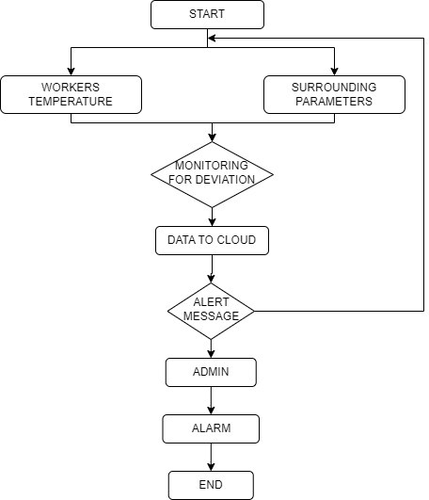

**5.2 SOLUTION AND TECHNICAL ARCHITECTURE**

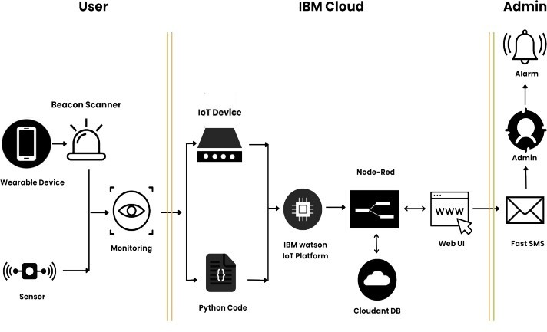

**CHAPTER 6**

**PROJECT PLANNING AND SCHEDULING**

**6.1 SPRINT AND EXPLANATION**

A sprint is a short, time-boxed period when a scrum team works to complete a set amount of work. Sprints are at the very heart of scrum and agile methodologies, and getting sprints right will help your agile team ship better software with fewer headaches.

The many similarities between agile values and scrum processes lead to a fair association. Sprints help teams follow the agile principle of "delivering working software frequently," as well as live the agile value of "responding to change over following a plan." The scrum values of transparency, inspection, and adaptation are complementary to agile and central to the concept of sprints.

**6.2 SPRINT DELIVERY SCHEDULE**





**Velocity:**

Imagine we have a 10-day sprint duration, and the velocity of the team is 20 (points per sprint). Let’s calculate the team’s average velocity (AV) per iteration unit (story points per day)

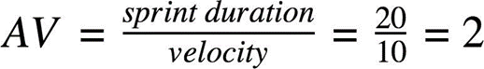

**CHAPTER 7**

**CODING AND SOLUTIONING**

**7.1 FEATURE 1**

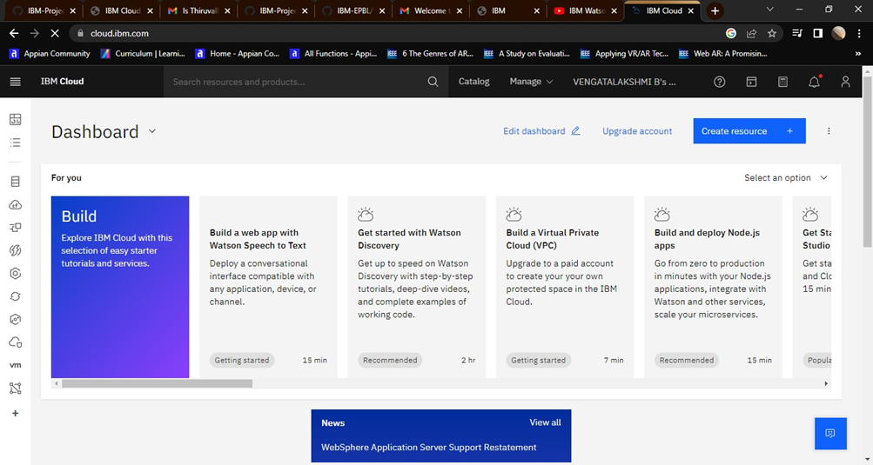

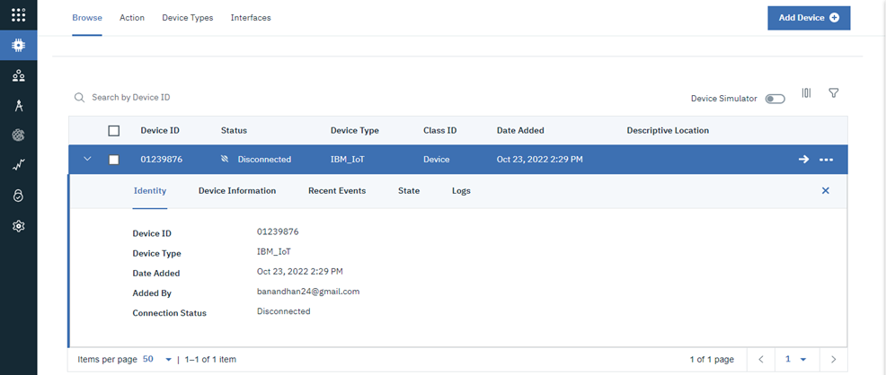

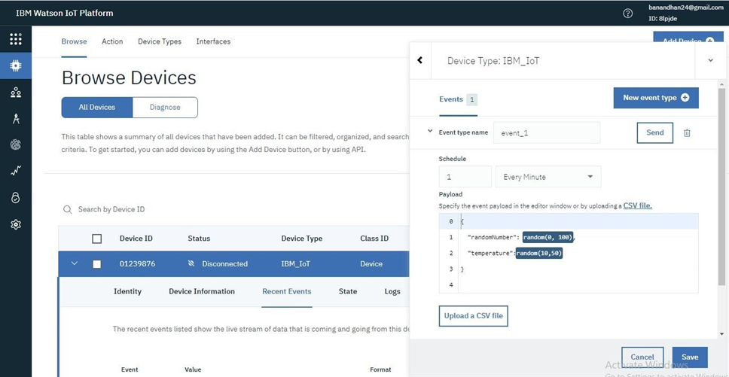

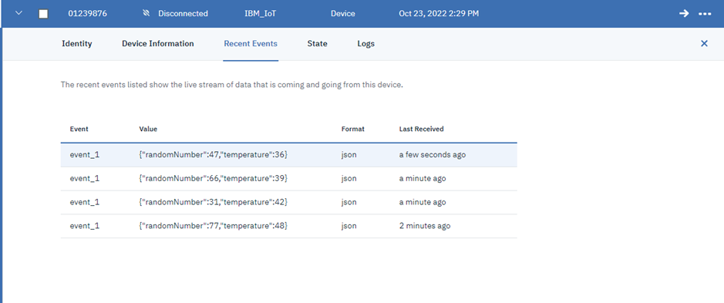

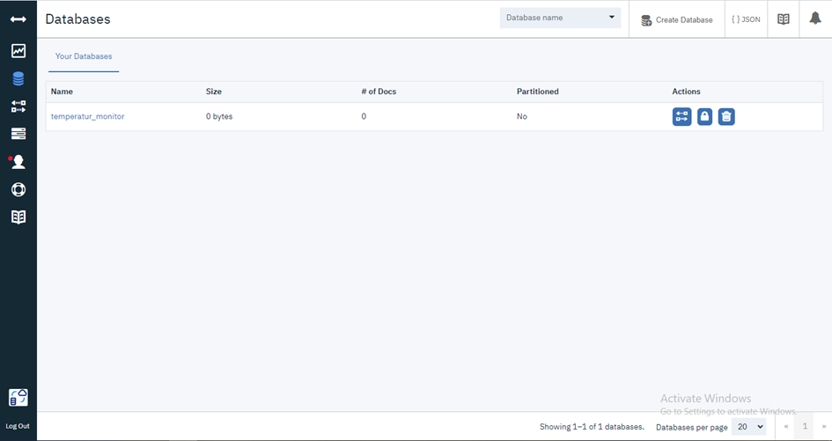

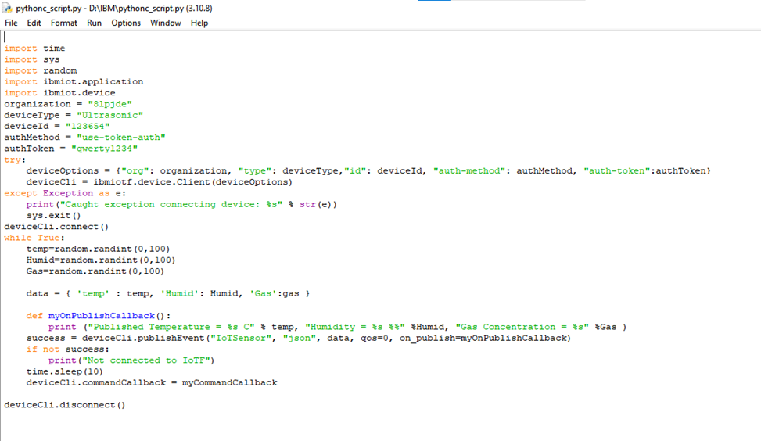

**7.2 FEATURE 2**

A milestone is a specific point within a project's life cycle used to measure the progress toward the ultimate goal. Milestones in project management are used as signal posts for a project's start or end date, external reviews or input, budget checks, submission of a major deliverable, etc.

|  |  |  |  |  |
| --- | --- | --- | --- | --- |
| **TITLE** | | **DESCRIPTION** | | **DATE** |
| **Literature Survey & Information Gathering** | | Literature survey on the selected project & gathering information by referring the, technical papers, research publications etc. | | 10 OCTOBER 2022 |
| **Prepare Empathy Map** | | Prepare Empathy Map Canvas to capture the user Pains & Gains, Prepare list of problem statements | | 12 OCTOBER 2022 |
| **Ideation** | | List the by organizing the brainstorming session and prioritize the top 3 ideas based on the feasibility & importance. | | 15 OCTOBER 2022 |
| **Proposed Solution** | | Prepare the proposed solution document, which includes the novelty, feasibility of idea, business model, social impact, scalability of solution, etc. | | 17 OCTOBER 2022 |
| **Problem Solution Fit** | | Prepare problem - solution fit document. | | 20 OCTOBER 2022 |
| **Solution Architecture** | | Prepare solution architecture document. | | 21 OCTOBER 2022 |
| **Customer Journey** | Prepare the customer journey maps to understand the user interactions & experiences with the application (entry to  exit). | | 22 OCTOBER 2022 | |
| **Functional Requirement** | Prepare the functional requirement document. | | 22 OCTOBER 2022 | |
| **Data Flow Diagrams** | Draw the data flow diagrams and submit for review. | | 30 OCTOBER 2022 | |
| **Technology Architecture** | Prepare the  technology architecture diagram. | | 30 OCTOBER 2022 | |
| **Prepare Milestone & Activity List** | Prepare the milestones & activity list of the project. | | 02 NOVEMBER 2022 | |
| **Sprint Delivery Plan** | Product backlog,  Sprint planning, Stories,  Story points. | | 05 NOVEMBER 2022 | |
| **Project Development - Delivery of Sprint-1, 2, 3 & 4** | Develop & submit the developed code by testing it. | | IN PROGRESS.. | |

**Publishing Data:**

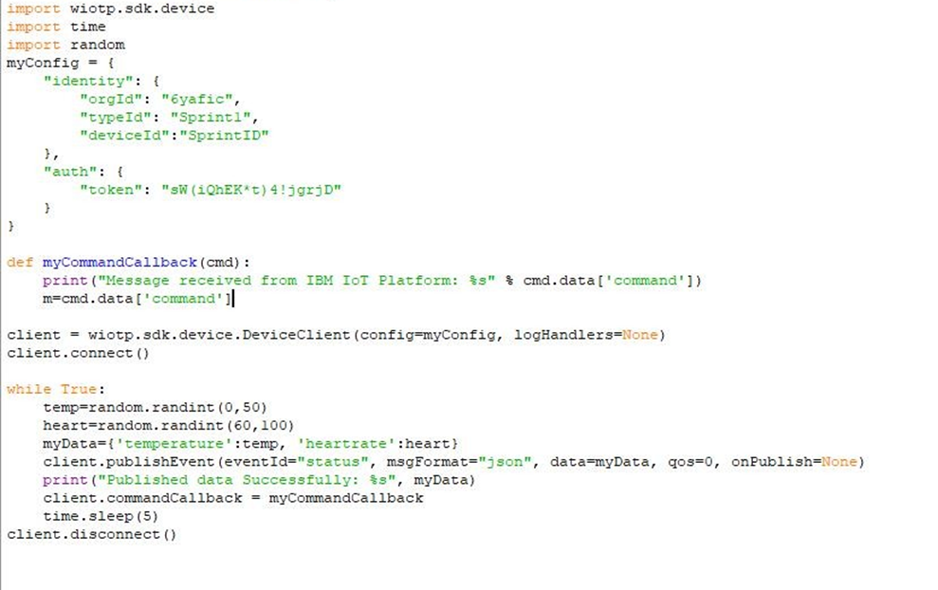

**Pythonscript:**

import wiotp.sdk.device import time

import random myConfig = { "identity": { "orgId": "6yafic",

"typeId": "Sprint1", "deviceId":"SprintID"

},

"auth": {

"token": "sW(iQhEK*t)4!jgrjD"

}

}

def myCommandCallback(cmd):

print("Message received from IBM IoT Platform: %s" % cmd.data['command']) m=cmd.data['command']

client = wiotp.sdk.device.DeviceClient(config=myConfig, logHandlers=None) client.connect()

while True:

temp=random.randint(0,50) heart=random.randint(60,100) myData={'temperature':temp, 'heartrate':heart}

client.publishEvent(eventId="status", msgFormat="json", data=myData, qos=0, onPublish=None)

print("Published data Successfully: %s", myData) client.commandCallback = myCommandCallback time.sleep(5)

client.disconnect()

**CHAPTER 8**

**TESTING**

**8.1 Test Cases**



**8.2 User Acceptance Testing**

**1. Purpose of Document**

The purpose of this document is to briefly explain the test coverage and open issues of the project at the time of the release to User Acceptance Testing (UAT).

**2. Defect Analysis**

This report shows the number of resolved or closed bugs at each severity level, and how they were resolved

|  |  |  |  |  |  |  |  |  |  |  |  |
| --- | --- | --- | --- | --- | --- | --- | --- | --- | --- | --- | --- |
| **Resolutio n** | | **Severi ty 1** | | **Severi ty 2** | | **Severi ty 3** | | **Severi ty 4** | | **Subtot al** | |
| By Design | | 10 | | 4 | | 2 | | 3 | | 20 | |
| Duplicate | | 1 | | 0 | | 3 | | 0 | | 4 | |
| External | | 2 | | 3 | | 0 | | 1 | | 6 | |
| Fixed | | 11 | | 2 | | 4 | | 20 | | 37 | |
| Not Reproduced | | 0 | | 0 | | 1 | | 0 | | 1 | |
| Skipped | | 0 | | 0 | | 1 | | 1 | | 2 | |
| Won't Fix | | 0 | | 5 | | 2 | | 1 | | 8 | |
| Totals | | 24 | | 14 | | 13 | | 26 | | 7  7 | |

3.Test Case Analysis

This report shows the number of test cases that have passed, failed, and untested

|  |  |  |  |  |
| --- | --- | --- | --- | --- |
| **Section** | **Total Cases** | **Not Tested** | **F**  **ail** | **Pa ss** |
| Print Engine | 7 | 0 | 0 | 7 |
| Client Application | 51 | 0 | 0 | 51 |
| Security | 2 | 0 | 0 | 2 |
| Outsource Shipping | 3 | 0 | 0 | 3 |
| Exception Reporting | 9 | 0 | 0 | 9 |
| Final Report Output | 4 | 0 | 0 | 4 |
| Version Control | 2 | 0 | 0 | 2 |

**CHAPTER 9**

**RESULTS**

**OUTPUT SCREENSHOTS:**

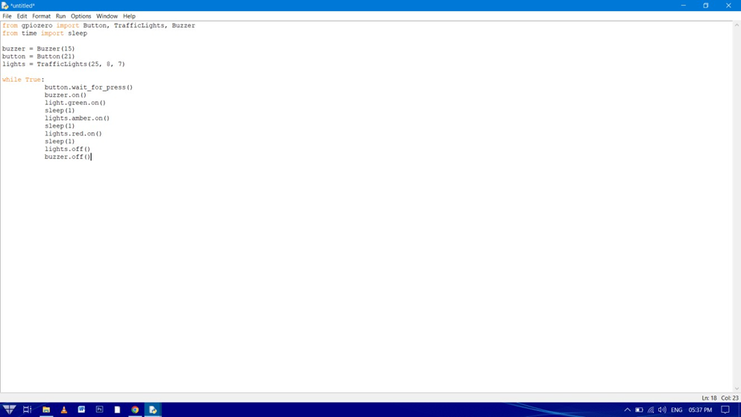

**CHAPTER 10**

**ADVANTAGES AND DISADVANTAGES**

**ADVANTAGE:**

**This system helps in the following ways:**

• The capability of sensing accurately with increased flexibility.

• Reduce human effort.

• Reliable and economical.

• If any of the sensor output will be high, Voice module will produce the sound for intimating the condition to others.

• Reduces the level of destruction.

• Simple and low cost technology.

• It has robust and simple construction.

• Automation of sensors leads to better monitoring of devices.

**DISADVANTAGE:**

1, Damage caused which beyond the sensor’s capacity still prevail2

2, Data can’t be accessed on time if there are any

internet issue

**CHAPTER 11**

**CONCLUSION**

Now-a-days, automation is a major part in industry. Earlier days monitoring of industrial situation takes place with the help of CCTV cameras. In order to reduce manual overhead in industries, we implement a GSM module based Embedded System concept. Through this project, we plan to get hands on knowledge onthe trending technologies of "Embedded System" and"Internet of things". The idea of "Industrial parameterSurveillance and Fault detection" was selected with a view ofstudying about the various industry variables, keeping trackof their changes and then deciding the threshold for thesame through NodeMCU and sensors. If these parametersdeviate from the threshold they passes potential hazard tothe plant and the whole industry as well. Therefore we havealso included some fault detection and prevention actuatorslike fan, exhaust, LEDs, buzzers. The role of IOT in ourproject is the data collection and communication over theinternet.

This Arduino based embedded system concept is to monitor and control industrial parameter such as (temperature, gas, fire, humidity) and inform to responsible person to take appropriate action.